**DAILY ONLINE ACTIVITIES SUMMARY**

|  |  |  |  |  |  |  |  |  |
| --- | --- | --- | --- | --- | --- | --- | --- | --- |
| **Date:** | **13/06/2020** | | | | | **Name:** | **Archana J C** | |
| **Sem & Sec** | **4th**  **‘A’** | | | | | **USN:** | **4AL18CS011** | |
| **Online Test Summary** | | | | | | | | |
| **Subject** | | **Data communication** | | | | | | |
| **Max. Marks** | | **30** | | **Score** | | | **29** | |
| **Certification Course Summary** | | | | | | | | |
| **Course** | **Python and Django full stack web developer bootcamp** | | | | | | | |
| **Certificate Provider** | | | **Udemy** | | **Duration** | | | **2hours** |
| **Coding Challenges** | | | | | | | | |
| 1. **Write c program to calculate the electricity bill** | | | | | | | | |
| **Status: Completed** | | | | | | | | |
| **Uploaded the report in Github** | | | | | **Yes** | | | |
| **If yes Repository name** | | | | | **https://github.com/alvas-education-foundation/archana_j_c** | | | |
| **Uploaded the report in slack** | | | | | **Yes** | | | |

Online Test Details: (Attach the snapshot and briefly write the report for the same)

The online test is from Data communication, which includes Introduction to data communication, networks, The Internet, protocols and standards, Digital to digital conversion, Bi-phase, analog to digital conversion, aspects of digital to analog conversion etc. The test is for 30 marks and the duration is 30 minutes. The score which I got is 29/30.

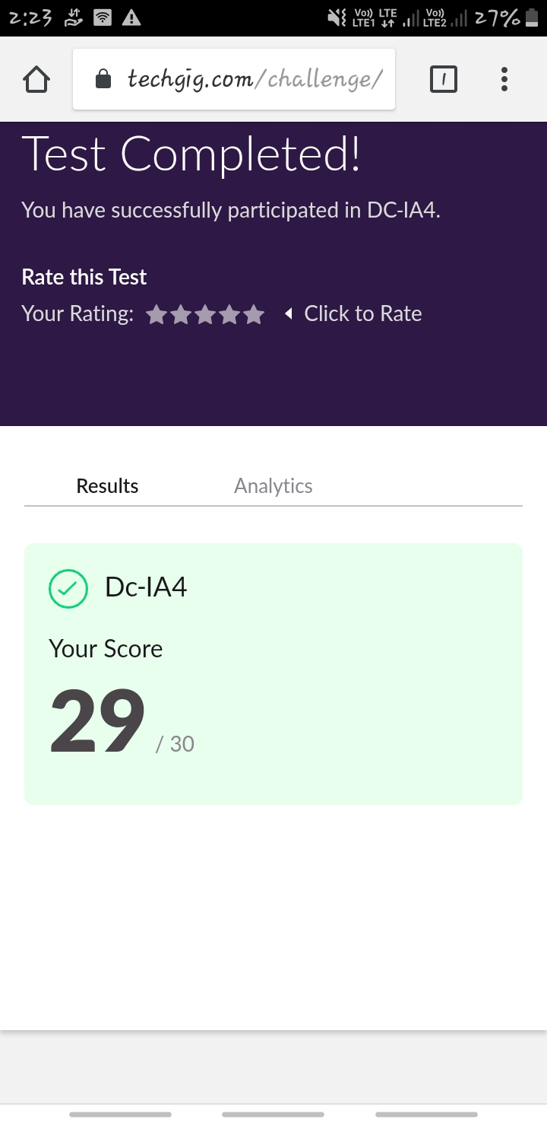

Certification Course Details: (Attach the snapshot and briefly write the report for the same)

COURSE NAME : **Python and Django full stack web developer bootcamp**

CERTIFICATION PROVIDERS : Udemy

The course is all about the web development. I was learnt about html and css, and how to code using html and I’m know in javascript advance.

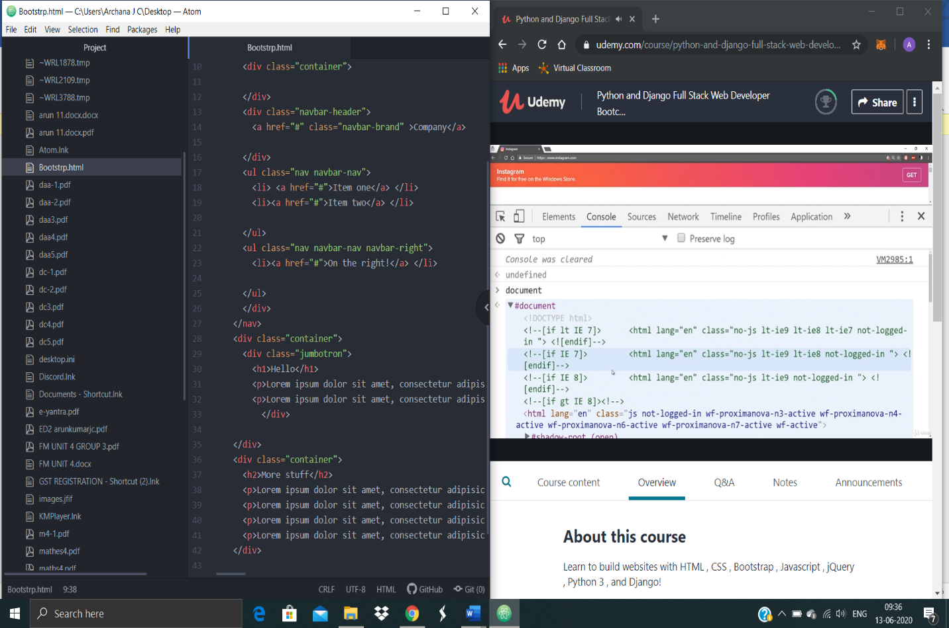

Coding Challenges Details: (Attach the snapshot and briefly write the report for the same)

Today I’m done with some python programs. The solution are already uploaded in github repository

**Program1 :** **Write c program to calculate the electricity bill.**

